
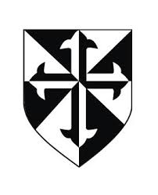


St Malachy’s Infants’ School Newsletter
June 2026
Welcome!
As the school year comes to a close, we at St Malachy’s Infants School want to take this opportunity to thank you for all your support this year and wish you all a very happy and safe Summer.
It has been a very busy year and everyone has been working very hard. Here is a reminder of some of the exciting things that have happened this year and what to expect over the next couple of weeks!

Feis Drámaíocht  Congratulation to Mrs Keller’s 1st Class, who came 1st in Dundalk’s Feis Dramaíocht in March in the Town Hall.  They progressed to the Leinster Final in Mullingar, where they were very highly praised as the youngest competitors.  Special mention to Giuseppe Caso who won best actor. Maith sibh! | 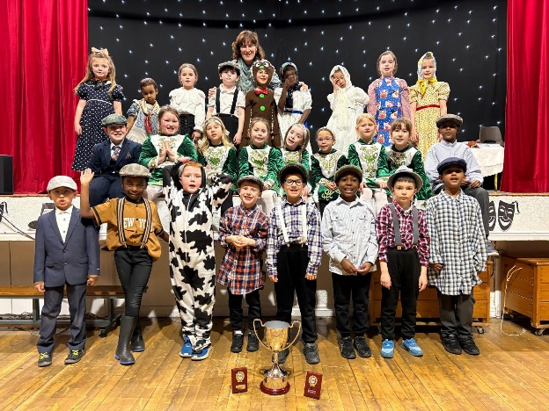
Seachtain na Gaeilge – Lá Glas  We had great fun during Seachtain na Gaeilge. We had a Ceilí in the Youth Centre. Thank you to Mrs Keller for all her hard work teaching us the moves.  For Lá Glas - we all wore green to schooI and had a lovely parade through town! We could be heard before we were seen, it was as good as the actual St. Patrick’s Day Parade!  https://www.stmalachysinfants.ie/news/l-glas-/?p=2&tags=,1081, | World Book Day  On March 5th we celebrated World Book Day. All the children and staff came to school dressed as their favourite characters. We all had lots of fun! Some are already planning next year’s costume!  https://www.stmalachysinfants.ie/news/world-book-day-2026/?p=2&tags=,1081,
Grandparents Day  On the 22nd of April we welcomed the grandparents of the First Class children to enjoy a very special visit to the school.  The children performed a collection of songs, poems, dances and drama to entertain their adoring audience. The day concluded with a visit to the classrooms to reminisce.  Everyone enjoyed the day and we would like to thank all the Grandparents! | Green Schools Committee  In April, we launched our first Green Schools Committee. The committee's permanent members are Cáragh Fogarty, Sarah Mashinini, Alex Durnin, and Ronan Meehan.  They were joined by Aifric Holland, Zahra Mae Patras, Cole Bailey, Dylan Coyle, Charlie Ward Lavin, Leon Mc Guinness, Éabha Burns, Kenzie Kelly-Mulligan, Willow Dorian, Noah Millen, Jack O’Reilly and Rebecca Byrne, who together formed our very first Green Team and helped promote environmental awareness and sustainability throughout the school.  
Collections – Recycling
Don’t forget to keep bringing in your bottles, stamps and batteries!
Spring Clean Day  On 15th May the children took part in our annual spring clean. They arrived to school equipped with dustpans, brushes and cloths; we even had a wheelbarrow! Everyone worked so hard and the school grounds were sparkling. We even made the local newspaper!  https://www.stmalachysinfants.ie/news/spring-clean-up--/?p=1&tags=,1081, | Active School Week  The children enjoyed a wonderful week of activities from 2nd - 5th June. They participated in a whole school walk, dancing with Funky Feet, games with Mix it up sports, football skills with Dundalk Gaels, circuits and a bounceathon! Their enthusiasm was amazing and most importantly the children learned about the many benefits of being active which include; keeping their bodies healthy and strong, improving their mood, confidence and overall wellbeing.
Special Class  We are pleased to inform you that we received notice from the Department of Education that work will be starting soon on our special class.  We look forward to welcoming the new pupils in the new school year. | School Tours  Junior Infants and Senior Infants enjoyed their recent school tours to Fort Evergreen and Newgrange Farm.  First Class are looking forward to their upcoming trip to GR8 in Castleblaney.
Feis Mhuirtheimhne    Well done to all the children that participated in the Féis this year. We had 18 entries from the Infant School, two children from each class. We were very proud of each and every child and are delighted to announce that we collected 7 medals in total and shared 1st place overall in the poetry section with Knockbridge School.  The medals were awarded as follows:  Junior Infants:  Two 2nd places Fiadh Martin and Ída Holland  Senior Infants:  2nd place Niamh Conroy and 3rd place Jude Toner  First class:  Two 2nd places – Emily Mc Ardle and Aifric Holland and 1st place Tyrell Chiduza  We have the trophy proudly on display!  https://www.stmalachysinfants.ie/news/feis-mhuirtheimhne-success/?p=1&tags=,1081, | Retirement  At the end of June, we will be saying farewell to Ms Galligan, Principal of the Girls School and our valued colleague, as she retires after an incredible 48 years of dedicated service to the school.  We wish her every health, happiness, and success in her retirement.
Dates for your Diary

Sports Day: TBC

First Class Prayer Service: Wednesday 17th June

First Class School Tour: Tuesday 23rd June

Summer Holidays: School Closes Friday the 26th June at 12:00 for the Summer.

School re-opens on Thursday 27th August 2026 for the new school year
Social Media  Please be sure to keep an eye on the school website: www.stmalachysinfants.ie and Class Dojo for news and information about all the fantastic things that are happening in the school. | 

St Malachy’s Infants’ School would like to wish you all a very pleasant summer.
We look forward to seeing you all in the new school year!

